http://www.csl.mtu.edu/cs3331.ck/www/ChromeBall.gif**Week1 Homework Assignment**

* The program before each &runs in the background.

“|”is the Unix pipe operator. If you use a | b, where a and b are two programs, the stdout of a becomes the stdin of b

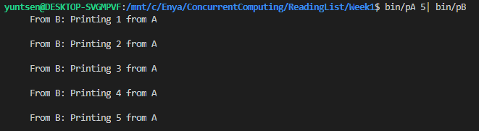

* Use these programs (*e.g.*, pA.c and pB.c) to practice I/O redirection operators > and <.

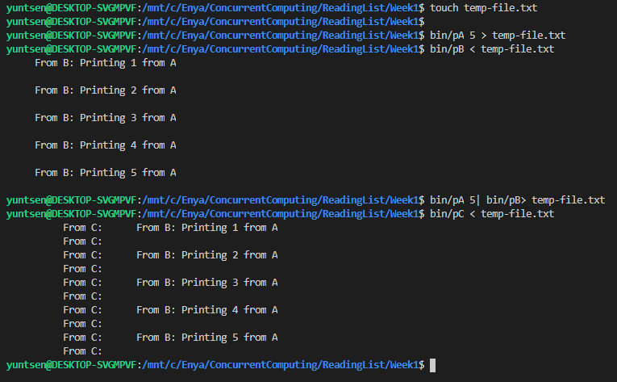

* Learn to use the Unix commands ps, top and kill as discussed in class.
* Run a program with an infinite loop in the background, find the process ID of this program with the ps command, and use the kill command to terminate it.
* Run a program with an infinite loop in the foreground, move to another window, find the process ID of this program with the the ps command, and use the kill command to terminate it.
* Do the same with the INT option rather than KILL. What does the INT option mean?

SIGINT is equivalent to pressing Ctrl+C on the keyboard

* Do the same with the TERM, and QUIT options rather than KILL. What does these two options mean?

SIGTERM(15) is not related to any terminal handling, and can only be sent from another process. This would be the conventional signal to send to a background process.

SIGINT(2) and SIGQUIT(3) are literally "interrupt" or "quit", "from keyboard", giving the user immediate control if a program would go haywire. With a physical character based terminal this would be the only way to stop a program!

* Run a program with an infinite loop in the foreground, use the **Ctrl-Z** key to suspend it, use the bg command to make this suspended program running in the background, and use the kill command to terminate it.

Background-running program cannot be suspend by ctrl+z key.